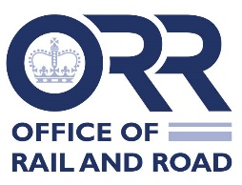
Broker confirmation of details of third party liability insurance maintained by:
Name of operator: | Company number:
I confirm that the third party liability insurance policies listed below covering the above named operator:
- meet the terms set out in ORR’s General Approval for operators’ third party liability insurance arrangements, dated 23 February 2007 (as amended by any relevant variation); and
- comprises a total level of indemnity of not less than £155 million [enter other amount only if appropriate] per incident in respect of liabilities which arise out of the rail operations of the above operator.

Insurer | Policy number | Amount insured | Start date | Expiry date
 | Total
Geographical coverage

Note: where part of any level of indemnity is provided by an industry facility, the broker should name that facility.
I understand that this letter could be placed on the ORR websites or otherwise made publicly available.
Signed:
Name:
Position of signatory:
(Director or authorised person)
Date:

Excluding clause 3h, which we expect the operator to confirm

