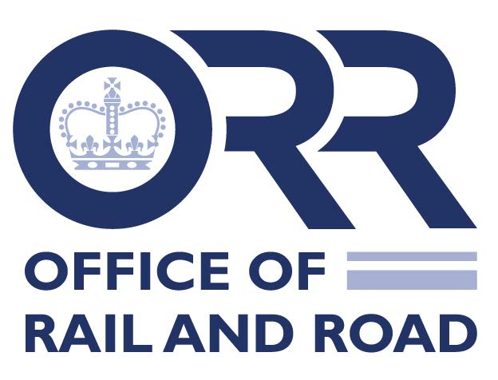

ROGS Duty of Cooperation - Escalation of disputes to ORR
- Your details
NB We recommend that all dispute parties escalate jointly to ORR. If this is not possible, please list other interested parties at 1B. Please be aware that we are likely to share this template with them, including any documents attached. Parties should have exhausted all dispute resolution processes within the industry before they escalate to ORR.
Involved parties

Company 1 Company 2

Name | Click or tap here to enter text. | Name | Click or tap here to enter text.
Position | Click or tap here to enter text. | Position | Click or tap here to enter text.
Address | Click or tap here to enter text. | Address | Click or tap here to enter text.
Email | Click or tap here to enter text. | Email | Click or tap here to enter text.
Work Tel Number | Click or tap here to enter text. | Work Tel Number | Click or tap here to enter text.
Mobile | Click or tap here to enter text. | Mobile | Click or tap here to enter text.

Other interested parties

Name | Click or tap here to enter text. | Name | Click or tap here to enter text.
Position | Click or tap here to enter text. | Position | Click or tap here to enter text.
Address | Click or tap here to enter text. | Address | Click or tap here to enter text.
Email | Click or tap here to enter text. | Email | Click or tap here to enter text.
Work Tel Number | Click or tap here to enter text. | Work Tel Number | Click or tap here to enter text.
Mobile | Click or tap here to enter text. | Mobile | Click or tap here to enter text.

- Summary of dispute (including areas where agreement has already been reached)
Please give a brief summary:
Click or tap here to enter text.

RIS-8270-RST dispute? | Yes ☐ | No ☐

Issues involved:

Safety | Click or tap here to enter text.
☐
Technical | Click or tap here to enter text.
☐
Commercial | Click or tap here to enter text.
☐

For RSD Admin use:

Safety operations/policy | ☐
Interop/standards | ☐
Track access/RME | ☐

- Brief history of dispute so far

RSSB Duty of Cooperation process followed? | Yes ☐ | No ☐
Senior management meetings? | Yes ☐ | No ☐
Reasonable request letters? | Yes ☐ | No ☐
If yes, please give details:
Click or tap here to enter text.

For RIS-8270-RST disputes:

Compatibility forum held? | Yes ☐ | No ☐

If yes, please give details:
Click or tap here to enter text.

Do you consider that all the industry processes have been exhausted?

Yes ☐ | No ☐

Have you contacted anyone in ORR so far?

Yes ☐ | No ☐

If yes please provide details:
Click or tap here to enter text.

- What are you expecting ORR to do to help resolve the dispute? Please give details:
Click or tap here to enter text.

Please send the completed form to rogs@orr.gov.uk.

