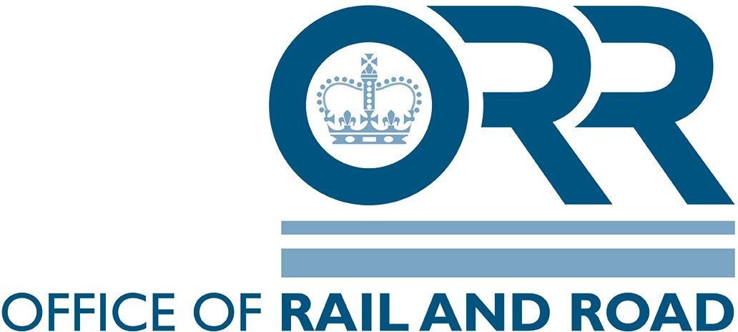
RM32019
Organisational Culture

Organisation Name:
Team/Area/Division assessed:
RM3 assessment by: |  |  |  |  |  | Date:
 |  | SP | OC | OP | PI & RCS | MRA | Row totals
Excellence | Continually improving
Predictable | Cooperating
Standardised | Involving
Managed | Managing
Ad-hoc | Emerging
Not assessed
Organisational culture maturity indicated level

